Observations from the review of “WRAP_Facility_CAPs Summary xlx” and FHT2014NWEIv2_summary”

Airport/Airplane emissions
Mobile vs. Point Sources - While the emissions were focused on point sources, I want to note that the mobile sources-aircraft is mobile. When I discussed this with EPA I learned that they included airport emissions in our point sources instead of nonpoint mobile. I support their inclusion into the data review because AK has a lot of airports and airstrips and the emissions are relevant.

Marine Emissions
This data is insufficient. The spreadsheet identifies only one marine cargo handling port in the data set – Valdez Marine Terminal which is a private facility. The rationale to include this and not a facility that is used to support other industries i.e. mining results in inaccurate and insufficient data.

In the documentation files I have, the reviewer of the data noted that the ports reviewed were the following but I don’t see these in the data provided for NEI 2014.v2. It seems that that the only port listed was Valdex marine terminal. Fishing at Valdez would be at the city dock yet there is no data available and all of the following ports would be relevant to regional haze.

• Anchorage (major cargo center)
• Dutch Harbor (major seafood processing)
• Homer (ferry/fishing/cargo)
• Juneau (major cruise destination/ferry/fishing/etc.)
• Ketchikan (major cruise destination/ferry/fishing/etc.)
• Kivalina (port for large mine)
• Kodiak (ferry/fishing/cargo)
• Nikiski (industrial cargo)
• Valdez (oil tankers/fishing)

In the all sector summary Wrap crosstab, there are totals for each marine borough and they don’t match the NEI interactive map found online. For example, there are marine emissions for NW Arctic borough and North Slope Borough in the WRAP crosstab but not listed in the EPA website or in the “WRAP_Facility_CAPs Summary xlx” and “FHT2014NWEIv2_summary”. It would be good to include all the borough and port information but not all appears to be available in one place.

The SCC codes applicable to marine operations include the following and these would be similar to those assigned to airports and aircraft operations.
SCC | SCC Description
2280002100 | Marine Vessels, Commercial Diesel port
2280002200 | Marine Vessels, Commercial Diesel underway
2280003100 | Marine Vessels, Commercial Residual Port
2280003200 | Marine Vessels, Commercial Residual Underway

Why does this matter?
We have high levels of sulfur showing in the IMPROVE monitors and we tend to point the finger at international marine. It would be valuable to identify AK anthropogenic marine operations to show that it is very minor and would not support the high sulfur on the improve sites. We may not be able to quantify the international but this would support the approach we will take for not including control measures.

In the pivot table and NEIv2 Commercial Marine Emissions - there is a high level noted in the commercial marine vessels bar tab. This does not equate with the data in the tables provided with the v.2 data. I looked at EPA NEI 2014 v.2 interactive web site for the graphics I am including. https://edap.epa.gov/public/extensions/nei_report_2014/dashboard.html#process-db

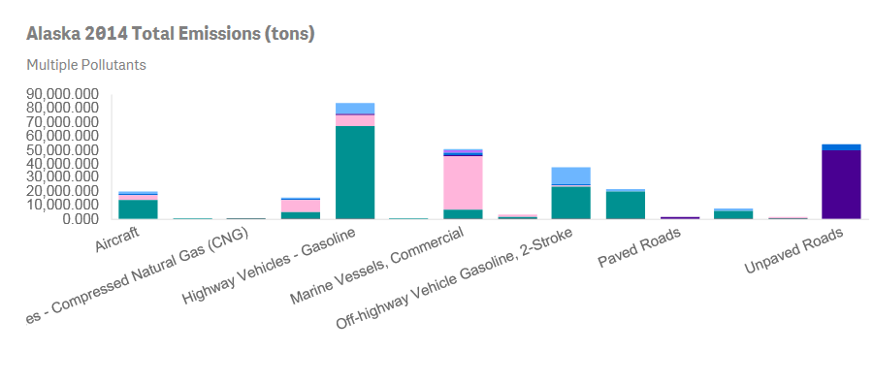

According to EPA, the data comes from the following portions of the State:
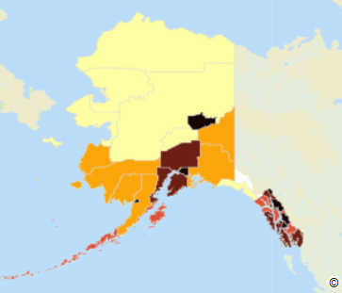

Dust
The levels in the unpaved road dust seem very high. We do have a dust problem but many rural locations would not affect Class I areas. The following map was completed recently and identifies rural communities that complain of dust. AK did not draft road dust data in 2014 and solely relied upon EPA. I think this number is high and additional data on non-paved road dust would be appreciated.

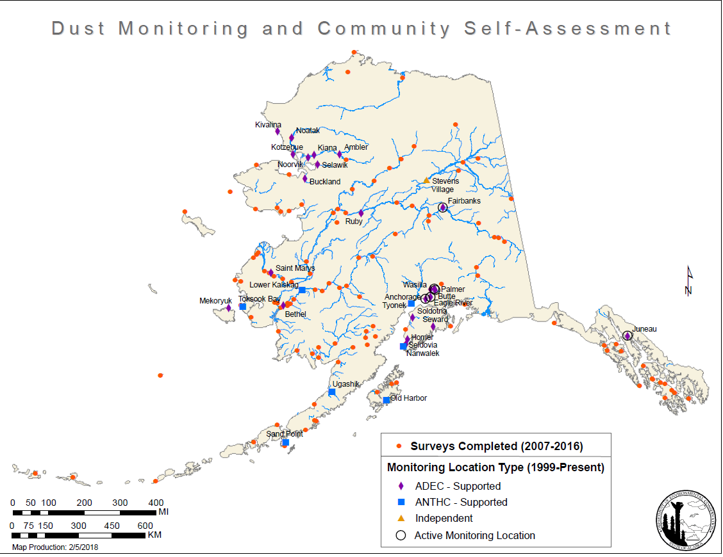

Wildfires
I admit we have really large fire years. In 2014 Alaska used specific vegetation types that represent the vegetation we have here. EPA used more general information for species in the lower 48. Still our numbers were close. For PM 2.5 prescribed fires we listed 7,316 tons and for Wildfires we listed 152,031 tons emitted. From what I can see in the Summary AK spreadsheet, EPA lists prescribed fires PM2.5 as roughly the same but wildfire PM2.5 is approximately 200,000+. This is a big difference. I would like to incorporate AK emission inventory for wildfires as I believe it is more accurate.

Oil and Gas
In looking at the data provided for the NEI 2014v.2 and am not sure it is complete. It may be for the oil and gas Type A and B sources. Why is it not complete? It seems AK did not report all the permits it has for the nonpoint data information. For example, mobile drilling rigs are not included, and I’m guessing that there are other smaller oil and gas activities and sources that are missing from the data but covered under a general permit. I don’t expect EPA to have this data in the NEI but at some point it would be nice to have. I will probably do a review and list for the O&G working group.

I will be looking at the data more specifically for the O&G WG.

